# CS 255 System Design Document

Dylan Dunagan

CS-255  
22 June 2025

## UML Diagrams

### UML Use Case Diagram

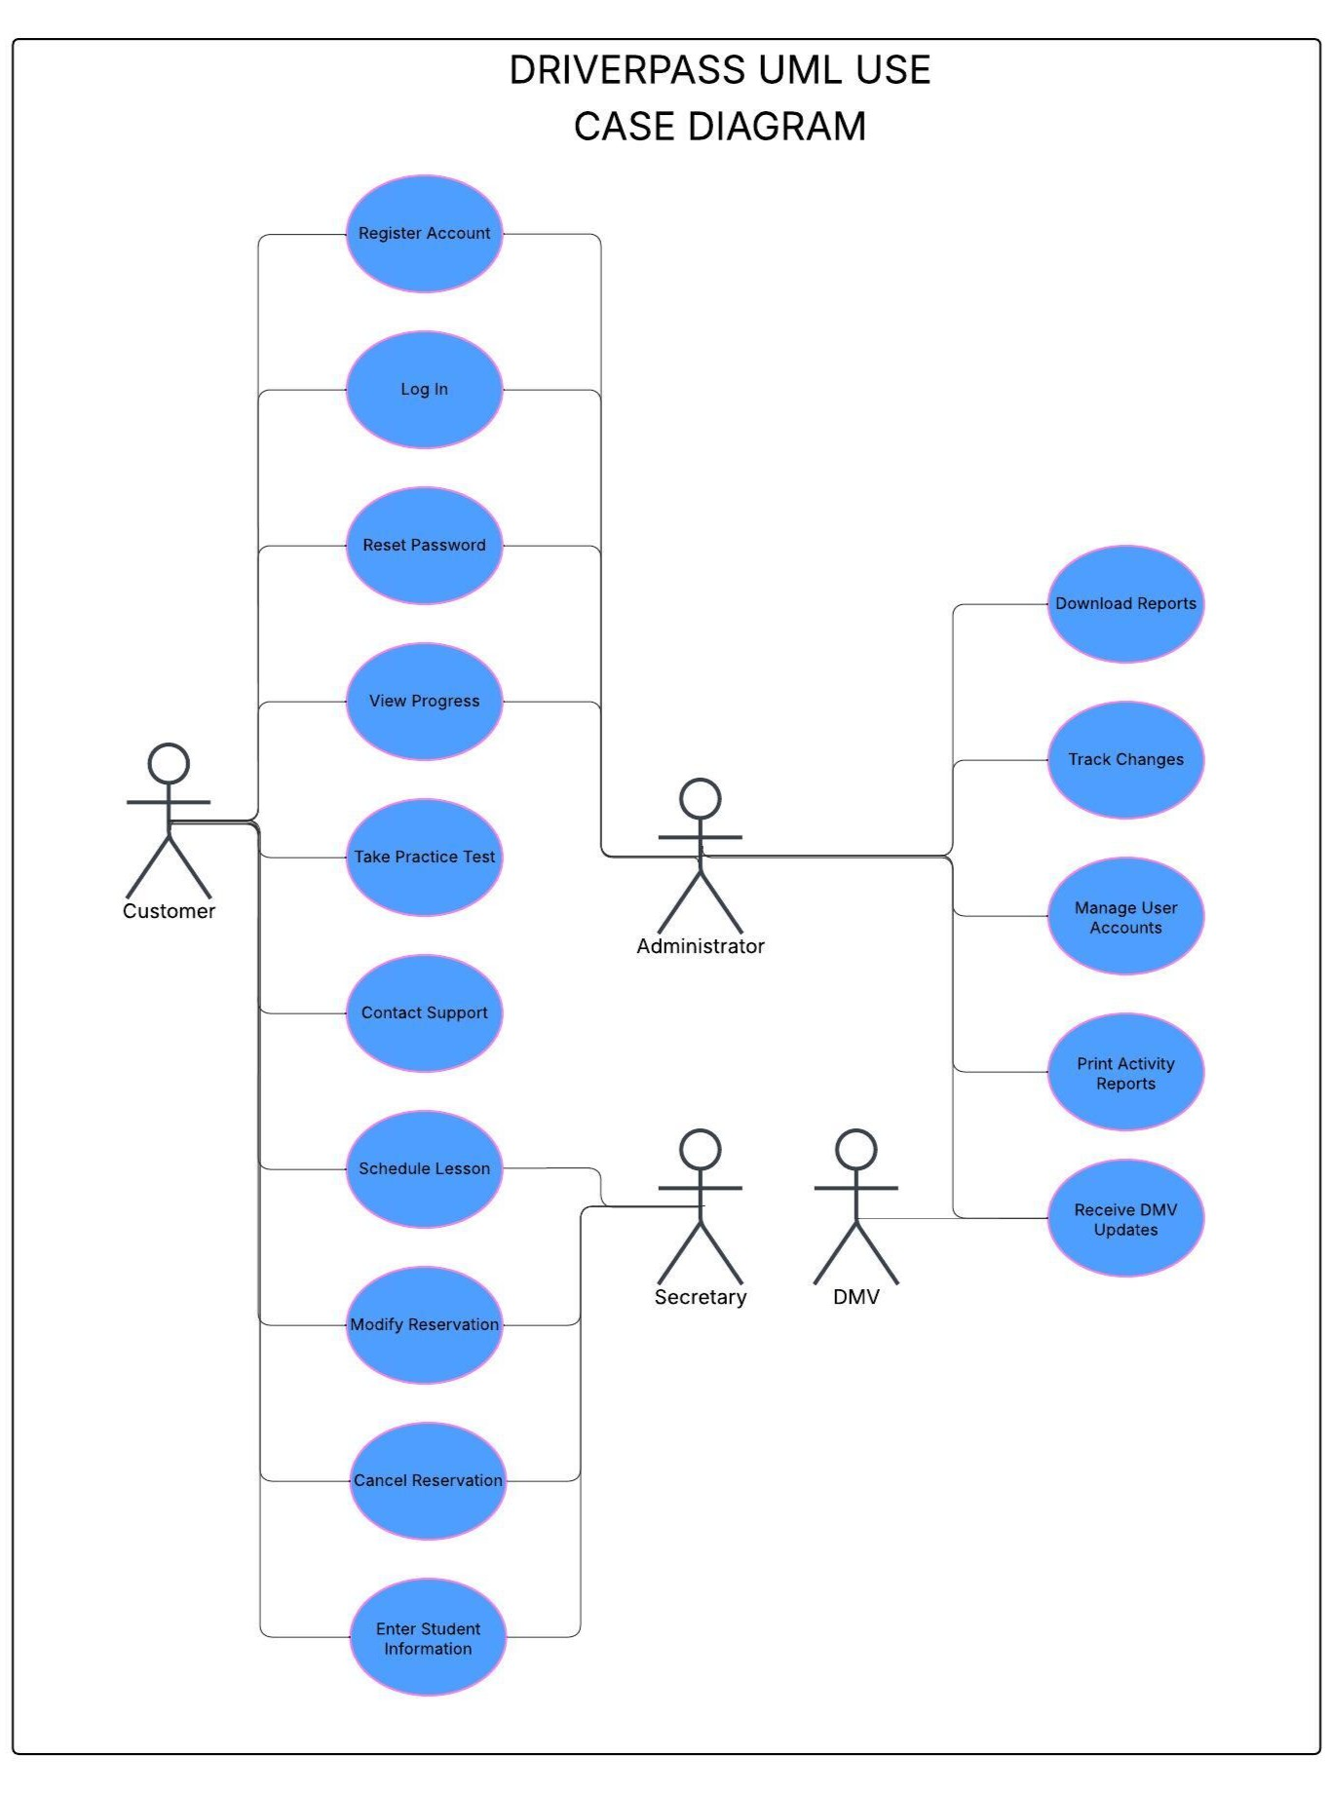

### UML Activity Diagrams

### UML Sequence Diagram

### UML Class Diagram

## Technical Requirements

The DriverPass system will require many different technical requirements. As for the infrastructure, the DriverPass system would benefit the most from an object-oriented programming language. The most common are Java and C++. C++ works well with high performance needs such as videogames while Java works better for a more consistent environment, such as web applications, business systems, and teaching and learning environments. Because of this the DriverPass system should be created using the Java language. One tool that will be needed is an integrated development environment software that is compatible with the Java language. This will allow for the programming and testing to be done easily. It will also allow for multiple programmers to collaborate on the system with little to no hassle in incorporating all the work. Since the DriverPass company wants the system to be cloud-based, another tool that will be needed is a server. The server will allow for the cloud-based system to exist and give the system a place to store all the various databases that will be required for the system to work properly. Those databases are user accounts, reservation scheduling, vehicles and instructors, and will also allow for any future updates that the system or the information on the system needs. For the infrastructure to be cloud-based, the whole system is required to be web-based, meaning that all users must have access to the internet. This does ensure that the multiple DMVs have easy and quick access to sending different regulation and law updates to the system. This ensures that all students and instructors are given the most current information and allows for the practice tests to be changed accordingly.